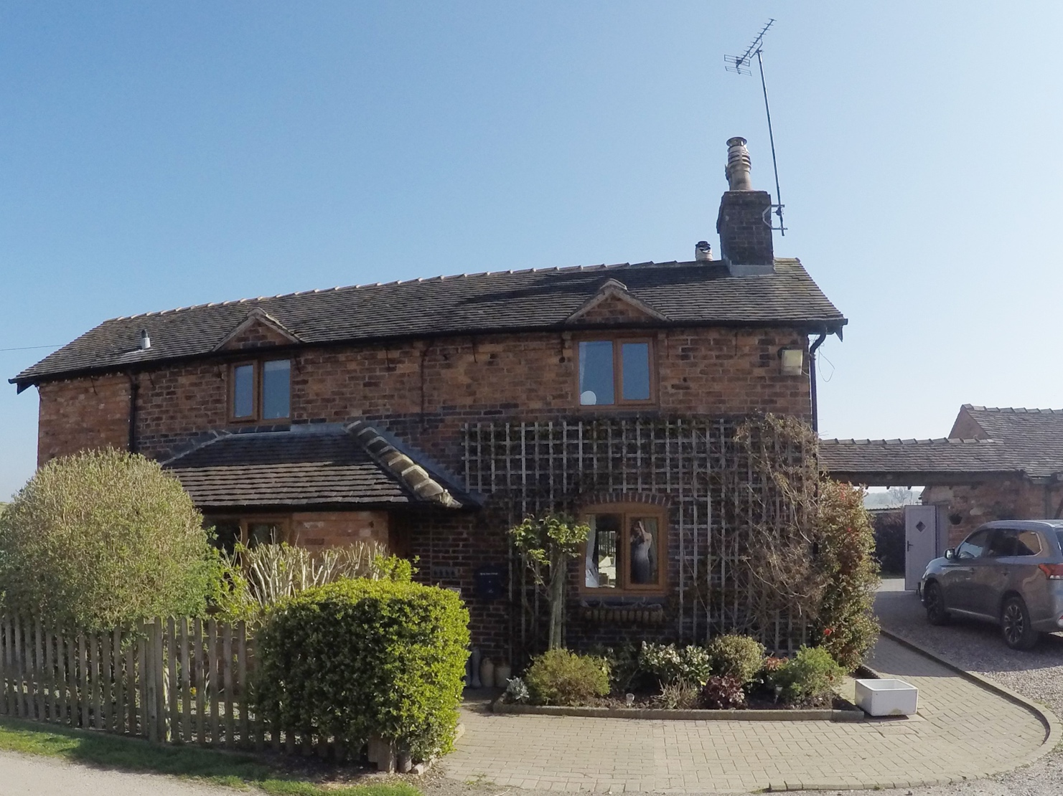
Quintessential Quarters
Gorsey Lane, Lower Hatton, Cotes Heath, Staffordshire, ST21 6SH

£950,000 Freehold Ref: 45420

Luxury Licensed Boarding Kennels & Cattery
Convenient yet delightful rural setting, immaculate purpose built facilities
Advised increasing turnover approx. £140,000 for 2019 with healthy profits
Stunning 4 bed detached renovated farmhouse, owners retiring

Description
This is a rare opportunity to acquire a long established
and highly regarded luxury Licensed Boarding Kennels and Cattery, which is located
at the heart of the Staffordshire countryside.

Quintessential Quarters occupies a peaceful rural setting, approached via a private gated driveway set in beautifully maintained grounds, whilst being surrounded by greenbelt countryside with delightful views.

Despite occupying such an idyllic setting the business is just a ten-minute drive from junction 15 of the (M6) motorway with the (A51) and major commuter routes close at hand.

Quintessential Quarters is therefore conveniently sited for the immediate locality, as well as neighbouring towns and villages, and subsequently attracts regular repeat and new custom throughout the Staffordshire, Cheshire, Birmingham and surrounding areas.

Having been in present ownership since 2013, this well-known business has acquired a truly enviable reputation as the leading boarding establishment in the area, and therefore boasts an extensive and loyal customer base enjoying frequent referrals and recommendations.

Quintessential Quarters is successful due to its good name and there is a genuine opportunity for purchasers to continue to build and develop the business from the existing customer base, with the opportunity to also introduce a retail shop, both on site and with an e-commerce facility, actively promoting the doggie day boarding as well as accommodating smaller animals such as guinea pigs, rabbits, birds etc.

In addition to providing boarding facilities, the business also offers a popular grooming service which is available to both boarding and non-boarding animals.

Quintessential Quarters is a thriving and highly lucrative business which would prove to be an excellent investment for an ambitious family who are seeking a fantastic lifestyle opportunity.

This is a rare opportunity to acquire an excellent business and a beautiful home which is only now being offered for sale due to retirement. To avoid disappointment, viewing is highly recommended.

Licensed Numbers
The business is licensed for 36 dogs in 15 units and 48 cats in 15 units.

Sales
Dogs
Off Peak - £23.50 per day
Peak - £29 per day
Treadmill sessions – £17

Cats

- VIC Pens - £13.45

- VIC - £11.45 for 2nd
or 3rd cat sharing
- LUXURY- £11.45
- LUXURY - £9.45 for
2nd or 3rd cat sharing
Peak rates
- VIC - £14.45
- VIC - £12.45 for 2nd or 3rd cat sharing

- LUXURY - £12.45
- LUXURY - £10.45 for 2nd or 3rd cat sharing
- Flying Starts £5
Accounts
Current records and accounts can be inspected after viewing.

Trading Hours
The business trades 08:30am to 18:00pm Monday to Sunday.

Staff
The business is managed by the owners with full/part time staff.

Building External
The property is approached via a private gated driveway and stands in beautifully maintained, well stocked formal landscaped gardens, patio and a summerhouse.

The main residence is a commanding and imposing double fronted detached farmhouse, which has been sympathetically modernised and updated to a superb standard,whilst maintaining its original charm and many character features.

The combination of the beautiful home and 3/4 an acre of stunningly landscaped gardens provide delightful family accomodation.

The gardens are an integral feature of the property, having been immaculately landscaped and presented. There is a large, contained, paved patio spanning the width of the residence and, just beyond the lawned garden, is the ornamental pond and water course.

Building Internal
The farmhouse has been modernised and updated to a high standard yet retains the original charm and character
of the property. The accommodation briefly comprises:

Entrance Vestibule – accessed via a covered entrance with stable doors.

Hallway – 12’11” x 12’, Beamed ceiling, quarry tiled flooring with under stairs cupboard for storage.

Guest Cloakroom/ W.C. – A two-piece suite in white, quarry tiled flooring.

Living Room – 17’ x 12’, A beautifully appointed room that oozes charm and character with a brick feature inglenook fireplace housing a wood burning stove, beamed ceiling, exposed timber flooring. The room looks out over the rear patio and gardens.

Dining Room – 12’2” x 14’, A welcoming and comfortable reception room with a wealth of character including a brick feature fireplace housing a wood burning stove, beamed ceiling, tiled flooring.

Orangery – A fabulous living space of powder coated aluminium construction with bi-folding doors and tiled flooring.
Breakfast Kitchen – 12’ x 14’6”, This is an impressive room which is ideal for a growing family. There is a comprehensive selection of quality ivory base units with complimentary laminated worksurfaces. The kitchen has a cream combi range, extractor unit, Belfast sink unit, Smeg dishwasher, breakfast bar, tiled flooring. The stable type door leads directly to the garden.

Utility Room – 7’6” x 5’ Wall and base units, sink unit, plumbing for automatic washing machine and vented for a dryer.

First Floor
Master Bedroom – 12’4” x 12’, A charming principle room with lovely views, a walk in dressing area and an en-suite shower room comprising: Wash hand basin, low level W.C., double shower cubicle, part tiled elevations, spotlighting. a freestanding bath, separate shower cubicle, wash hand basin, low level W.C.The bathroom has tiled elevations, and has recessed spotlighting.

Double Bedroom – 14’ x 12’1”, A good size bedroom with a beamed ceiling and views to the front of the property

Double Bedroom – 12’ x 11’7”, contains a feature chimney breast, recessed on either side, ideal for wardrobes.

Bedroom/Office – 7’3” x 9’2”, currently used as an office but could easily be a fourth bedroom. Contains fitted wardrobes and furniture.
Family Bathroom - A welcoming room which is light and airy with a suite comprising: Wash hand basin, bath, shower cubicle, low level W.C, part tiled elevations, beamed ceiling.

Kennels and Cattery
Reception
19’ x 8’3”, UPVC clad walls, tiled floors, ample power and telephone point.

Toilet/Laundry
UPVC clad walls, low level WC, wash hand basin, tiled floors, ceiling light and extractor.

Kennel kitchen
14’9” x 8’2”, laminated work surface with stainless steel sink, raised bath and hand shower attachment. Storage space.

Boarding Kennel Building
Supplied and built by BROXAP. These kennels are separate from the home. Set on a concreted base of metal framed, mesh and UPVC construction under a boxed profile roof.

There are 15 units, accessed by a rear covered corridor, each with stable-type doors, with weldmesh doors behind. They are the full height of the unit with, 5’ x 5’, with thermo-controlled tubular heater, humidifier fans and lights.

Pulley hatches allow access into external covered runs 8’2” in length with tiled flooring, division panels made of galvanised weldmesh. The weldmesh opens onto a covered outer corridor with drainage gulley and water point.

There are 4 holding kennels on an additional plot of rented land directly joined to the freehold plot, for use as required. This land is leased at £25 per annum.

Enrichment Area
This play area for the dogs is largely paved with grass and astro-turf areas.

Cattery
Supplied and built by Pedigree Pens. This luxury cattery, with panoramic views, is accessed by a paved path, is made of UPVC upon a concreted base, with a preparation kitchen attached.
There are 15 units, accessed via front runs, 6’ x 4’, with UPVC and glass divisions. Full height doors with flaps allow the cats free access between the runs and their full height accommodation with shelf.

All 14 units have thermos-static controlled panel heaters, with 4 having power points for heated beds and water fountains. 4 of the units have removable panels to extend the unit for multiple occupation. Smoked glass is used on end units.

Tenure
We are advised that the property is freehold.

We have been unable to check this information and advise prospective purchasers to consult their own solicitor for verification.

Summary
This is a rare opportunity to purchase a successful and highly lucrative business with a delightful family home which is located in such a desirable setting. Only now being offered for sale due to retirement, internal viewing is essential to avoid disappointment.

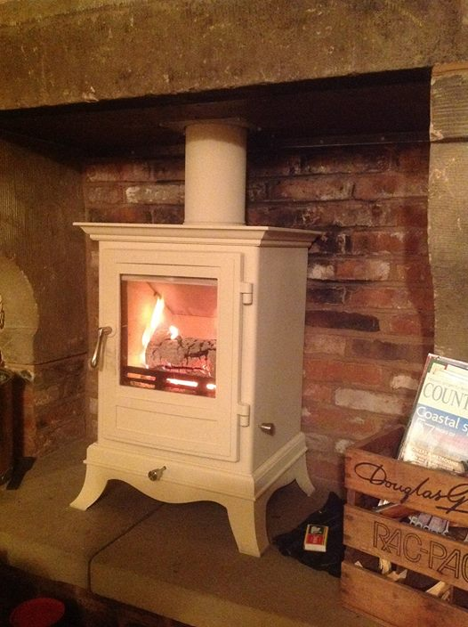
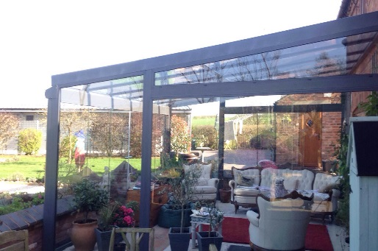
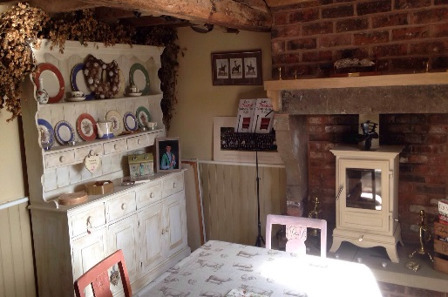
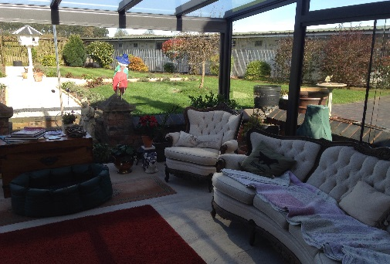
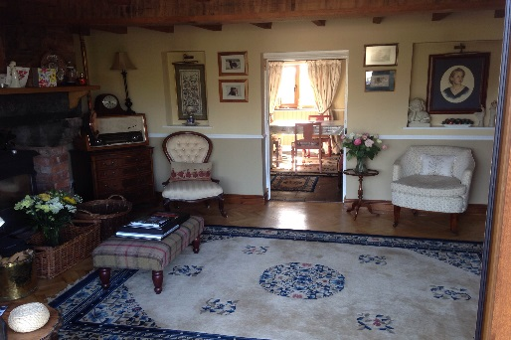
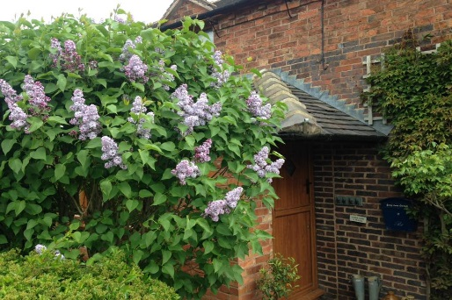
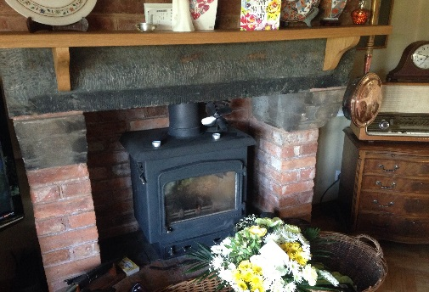
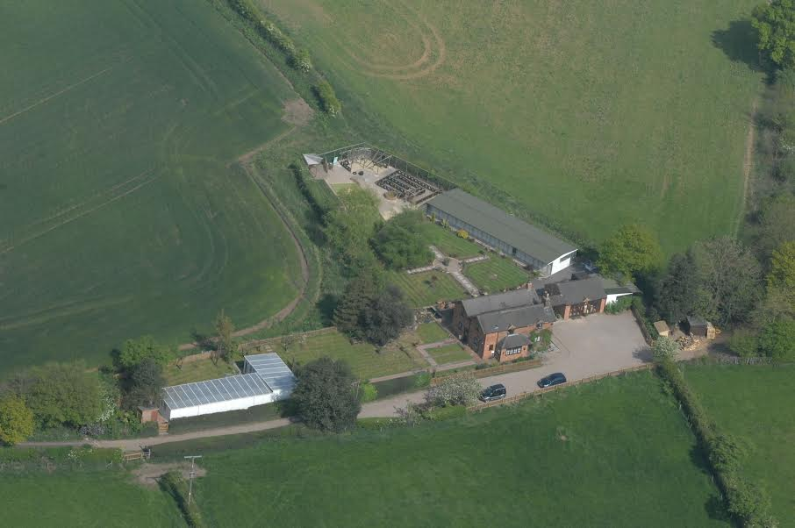
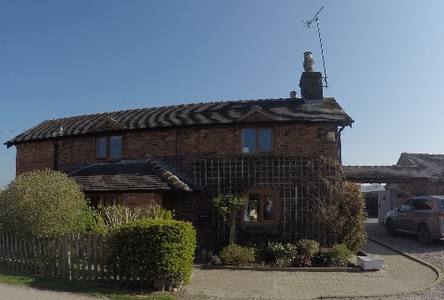
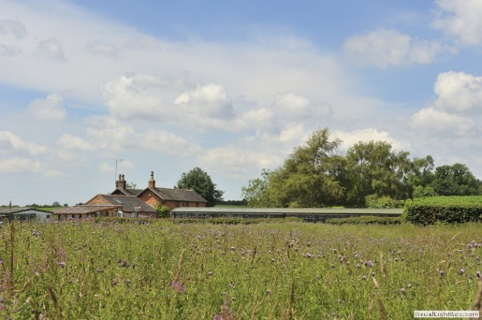
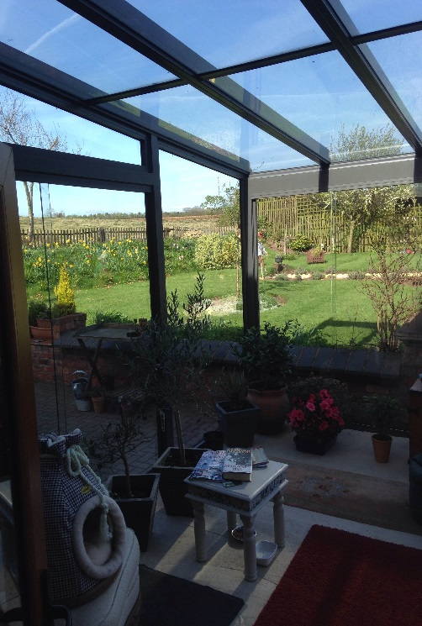
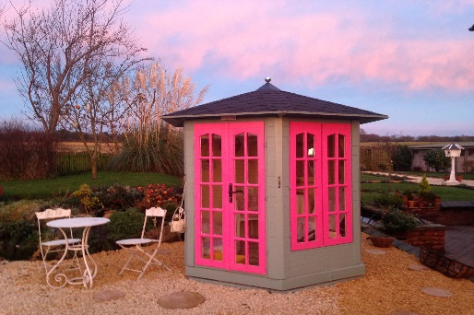
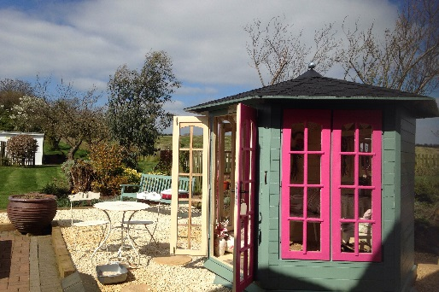
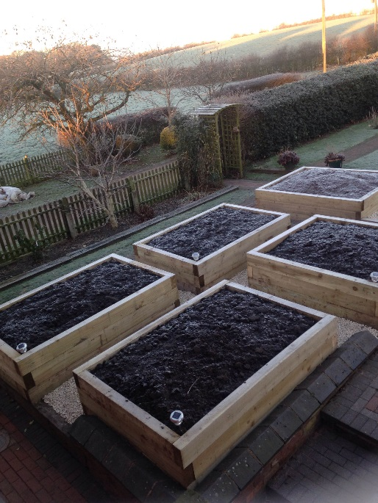
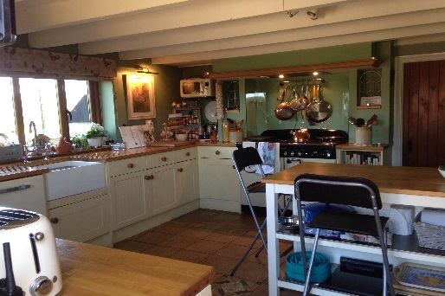
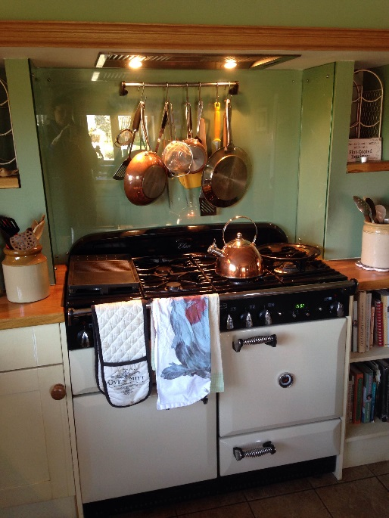

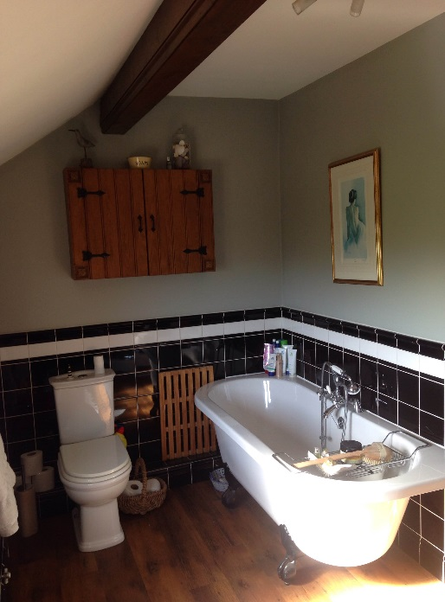

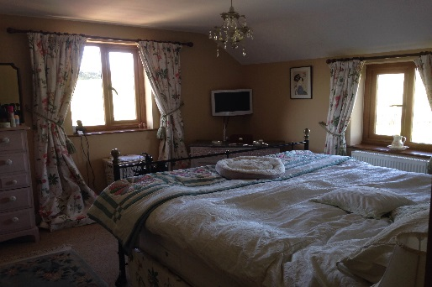
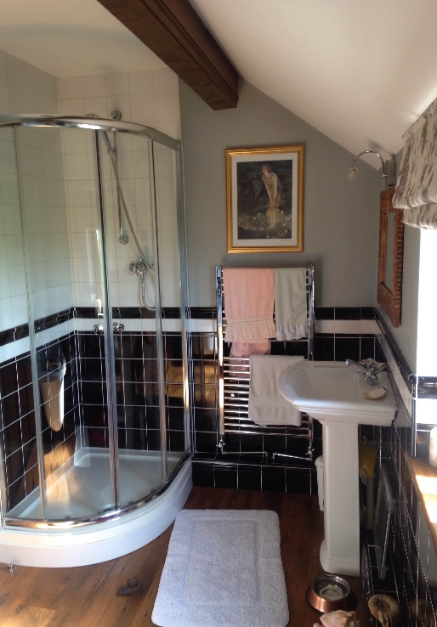
Kennels and Cattery
