

INFORMATION MEMORANDUM REQUEST
Tel: 01772 775 758
Email: info@kingscorporate.co.uk
https://kingsbusiness.co.uk/kings-corporate/

Twitter: @kings_bt
LinkedIn: kingscorporate

Eaves Brook House, Navigation Way, Preston PR2 PRY

INTRODUCTION
At Kings Corporate we understand that each business is unique, and we want to give your business the best possible representation. To do this we would like to work alongside you to obtain all the relevant information that will help us market your business to prospective buyers.
This document will allow our marketing team to create an ‘Information Memorandum’. The Information Memorandum is a key component of the marketing that we do for our clients. It serves as an all-encompassing, professionally written and designed brochure about your business, that we send to potential buyers once they have signed our non-disclosure agreement. It is highly important for yourself and us that this document is filled to the best of your knowledge.
Thank you.

BUSINESS OVERVIEW
A well known and highly respected independent Funeral Directors.
Established in 1956 and in current family ownership throughout.
Monopoly position with no competition within the town.
Truly enviable reputation – Regular referrals and recommendations.
Bryn Cadwaladr Dowell, Wyn Lloyd Dowell (50/50 Partnership)
Deceptively spacious and versatile detached freehold property.
Turnover £723,657 for the period 01.01.23 – 31.03.24 generating an EBITDA of £443,167
Retirement sale.

Please provide a description of the company and its main activities to help us build the unique story of your business. Include information such as products and services provided, turnover and employee numbers, property, location/s.

Trading Hours
09:00 – 17:00 (Monday – Friday)

On call 24 hours a day.
SECTOR OVERVIEW
Please provide a description of the current marketplace including an outline of key competitors (are they similar in size to your business?) the impact of covid-19, trends e.g. growing/shrinking, barriers to market entry and any thoughts you may have on future developments and opportunities.

CUSTOMERS
Please provide details of your top customers (by turnover). Note: This information can remain confidential if required.
Customer | Annual Sales £  (last full financial year) | Annual % of t/o | Length of relationship | Length of contract  (if applicable)

Please indicate below your number of active customers. Please also note your % of commercial v domestic customers.

Please provide details of any significant future pipeline including projects, contracts, order book value etc.

SUPPLIERS
Please provide information about your key supplier relationships. Note: This information can remain confidential if required.

Supplier | Product / Service | Annual Spend £ (last full financial year) | Length of relationship | Is a formal agreement in place? If YES describe terms

PRODUCTS & SERVICES
Please provide a brief description of the products/services that your company offers, including any new or planned product or service launches.
Please also provide a breakdown of revenue generated by product/service.

Product / Service | Income generated £ (last full financial year) | % of total income
Funeral services | £723,657 (period 01/01/23 – 31/03/24) | 100%

STRENGTHS & OPPORTUNITIES
Please highlight what you consider the particular strengths and unique selling points of your business that set you apart from the competition and will make your company attractive to potential purchasers (ideally 5-6). Also identify any potential opportunities for the future that may be of interest to a potential buyer such as work in progress, future contracts, new products, increased sales and marketing efforts, potential cost savings or new markets that could be explored.
Please describe your strengths
Potential opportunities

TRADEMARKS/ACCREDITATIONS/AWARDS
Please provide details of any trademarks, accreditations or awards that your business or specific staff members possess. And details of any trade bodies that you belong to.
Trademark/IP/Accreditation/Award | Further details / comments
Trade Associations | Membership type

SALES & MARKETING
Please provide an overview of your current sales and marketing activity. Please provide samples of marketing materials where possible.
 | Please X | % source of business |  | Please X | % source of business
Press/trade advertising |  |  | Referrals
Postal mailings |  |  | Digital marketing e.g. online ads/web enquiries
Email marketing |  |  | Direct sales (employ Business Development / Sales Reps)
Attend trade shows/exhibitions |  |  | Social media
Word of mouth/reputation | x | 100 | Other
What is your website address?
Please identify any active social media accounts
Any additional comments:

COMPANY OWNERSHIP
Please provide full company name, number and registered address. Please also provide a background history to the company with full details of current ownership, including (if applicable) how the share-holding is split.
Bryn Cadwaladr Dowell
Wyn Lloyd Dowell
50/50 Partnership.

SHAREHOLDER DETAILS
Name | Role | Shareholding (%)
KEY STAFF
Please provide a brief summary of your team and highlight any key strengths with regards to people, skills, staff turnover etc. Please include total number of employees who will be staying with the business post-completion.
The business is operated by the two brothers and their respective wife’s who are all seeking retirement post completion of sale.

Please give the current role of any members of staff that may have the attributes and may be capable of undertaking the roles of the current Directors

STAFF LIST
If you already possess a staff list/breakdown, please feel free to share that with us. If not, then please fill the staff list in the below format.
Job Title | Start Date | Years of Experience | Salary/Hourly Wage  (£) | Relevant  Qualifications
No staff post completion (family members)

ORGANISATION CHART
If possible, please provide an organisational chart, ideally in a format similar to the one shown below. Note: there is no need to include individual names.

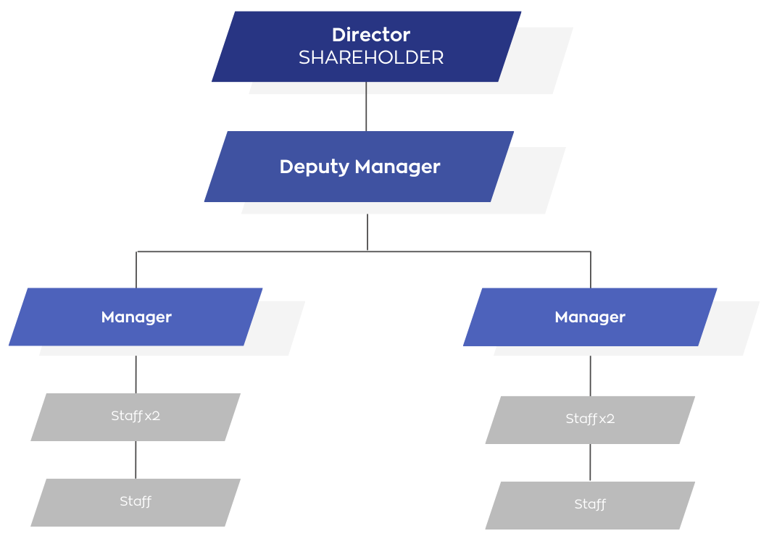

KEY MILESTONES
Please summarise any significant milestones in the history of the business. For example, company creation, expansions, ownership changes, major contracts won, awards/achievements etc.

Year | Milestone

PROPERTY DETAILS
Please provide a general description of the property/s, its use and any key features including approx. size, no. of floors/rooms and names/use of rooms, facilities, external features e.g. car park etc. Note: you are not limited to the box size below.
The detached property offers deceptively spacious and versatile lock up business accommodation. The accommodation briefly comprises: A welcoming open plan reception area, three offices, chapel of rest, mortuary, two stores, staff toilet. There is a lift providing access to the first floor. Located on the first floor of the property there are two workshops, previously a large open plan space which has been sub-divided and a store. Located to the rear of the property there is an integral garage with roller shutter access. There is also a separate two car garage. There is ample off-road parking to the front of the property.

Accommodation
There is no residential accommodation for owners/management available.

Please provide details of all property used across the business. If you have any supplementary information please provide e.g. floor plans, exterior and interior photographs, planning permission details, valuation reports etc.
Address | Freehold/  leasehold | Size (sq. ft) | Annual rent? | Expiry/renewal/ break clauses | Bricks & mortar value (if freehold) | Is the property included in the sale?
Tyn Y Parc, Ruthin, Clwyd, LL15 1LH | Freehold | Unknown | N/A | N/A | £600,000 (2015-2017)  John Hughes | Yes

Tenure
We are advised that the property is freehold.

We have been unable to check this information and advise prospective purchasers to consult their own solicitor for verification.
ADDITIONAL INFORMATION
It is essential we have as much information from you as possible. If you have not already done so, please provide the following:

 | Information checklist. Please indicate with X
Copies of the last three financial years accounts along with management accounts & any one-off costs incurred  This information will enable us to produce a valid picture of your financial performance to potential buyers and details of any anomalies in the accounts will enable us to substantiate a higher adjusted EBITDA. | X
Detailed asset/plant list
This information will provide potential buyers with any valuable assets that would contribute to the future performance of the business and are included in the sale.
Copies of corporate brochures and product literature
This will provide us with any additional information about the business not already included in this document as well as providing us with an idea of how the business is currently being marketed.
For property owned by the business, are there any recent valuation reports? If so, please provide copies
This will allow us to determine a more accurate sale value of the business.
Photography:
Please supply. Otherwise, if you would like us to arrange photography please indicate preferred times/days

THANK YOU FOR YOUR TIME AND CO-OPERATION

